What is Jenkins?
Introduction
Jenkins is a Continuous Integration (CI) server or tool which is written in java. It provides Continuous Integration services for software development, which can be started via command line or web application server. And also, it is happy to know that Jenkins is free software to download and install.
Continuous Integration
Before going in details to Jenkins, let me tell you what Continuous Integration (CI) is.
Continuous Integration (CI) is a development practice that requires developers to integrate code into a shared repository several times a day. It is a process of running your tests on a non-developer (say testers) machine automatically when someone pushes new code into the source repository. The below diagram shows the CI workflow.
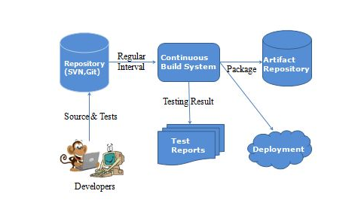
In this type of procedure, there is a huge advantage of knowing whether all the jobs (configured project in Jenkins) work properly or not. And also we can get fast feedback. The fast feedback is very important so you will always know, right after you broke the build. In the console, you will get the detailed log messages. From this, you will get to know what the reason for job fail was and you can also get to know how you can revert it back. Using an Artifact Repository in CI server will successfully deploy the built snapshot and release which is available to other developers.
If jobs run occasionally then the problem is that since the last time there will be a lot of code changes might have happened. So it will be hard to figure out which changes introduced the problem. But when it is set to run automatically on every code push then it is always easy to know what and who introduced the problem.

Some of the attractive reasons why you need automate build testing and integration are:
- Developer time is concentrated on work that matters: Most of the work like integration and testing is managed by automated build and testing systems. So the developer’s time is saved without wasting on large-scale error-ridden integrations.
- Software quality is made better: Issues are detected and resolved almost right away which keeps the software in a state where it can be released at any time safely.
- Makes development faster: Most of the integration work is automated. Hence integration issues are less. This saves both time and money over the lifespan of a project.
Continuous Build System can include tools like Jenkins, Bamboo, and Cruise Control, etc. Bamboo has better UX support but it is not a free tool. Jenkins is an open source tool, easier to setup and configure and also has a very active plug-in development community which makes it favored. Now, let us dive into the Jenkins tool.
Jenkins History
Jenkins was originally developed as the Hudson project. Hudson’s creation started in summer of 2004 at Sun Microsystems. It was first released in java.net in Feb. 2005.
During November 2010, an issue arose in the Hudson community with respect to the infrastructure used, which grew to encompass questions over the stewardship and control by Oracle. Negotiations between the principal project contributors and Oracle took place, and although there were many areas of the agreement a key sticking point was the trademarked name “Hudson” after Oracle claimed the right to the name and applied for a trademark in December 2010. As a result, on January 11, 2011, a call for votes was made to change the project name from “Hudson” to “Jenkins”. The proposal was overwhelmingly approved by community vote on January 29, 2011, creating the Jenkins project.
On February 1, 2011, Oracle said that they intended to continue development of Hudson, and considered Jenkins a fork rather than a rename. Jenkins and Hudson, therefore, continue as two independent projects, each claiming the other is the fork. As of December 2013, the Jenkins organization on GitHub had 567 project members and around 1,100 public repositories, compared with Hudson’s 32 project members and 17 public repositories.
Continuous Integration with Jenkins
Jenkins tool is heavily used in CI which allows code to build, deployed and tested automatically.
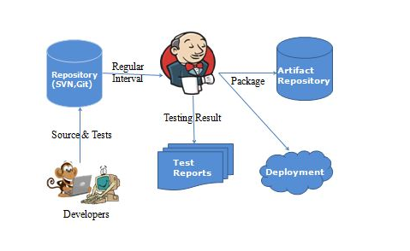
Let us depict a scenario where the complete source code of the application was built and then deployed on the test server for testing. It sounds like a robust way to develop software, but this method has many weaknesses. They are,
- Developers have to pause till the complete software is developed for the test results.
- There is a huge possibility that the test results might show lot many bugs. This makes developers be in a complex situation to find the root cause of those bugs since they have to check the entire source code of the application.
- Delivery process of software is slowed down.
- Continuous feedback referring to things like coding or architectural issues, build failures, test condition and file release uploads were missing so that the quality of software can go down.
- The whole process was manual which increments the risk of repeated failure.
It is obvious from the above-stated problems that along with slow software delivery process, the quality of software also went down. This leads to customer unhappiness. So, to overcome such confusion there was a crucial demand for a system to exist where developers can gradually trigger a build and test for each and every change made in the source code. Therefore, Jenkins tool is used in CI. It is the most mature CI tool possible. Now let us see how Continuous Integration with Jenkins crushes the above shortcomings.
For software development, we can hook it up with most of the repositories like SVN, Git, Mercurial, etc. Jenkins has lots of plugins that are available freely. These plugins help to integrate with various software tools for better convenience.
One really nice thing about Jenkins is, build configuration files will be on disk which makes massive build cloning and reconfiguring easy.
Advantages of Jenkins
- Jenkins is an open source tool with much support from its community.
- Installation is easier.
- It has more than 1000 plug-in to make the work easier.
- It is easy to create new Jenkins plugin if one is not available.
- It is a tool which is written in Java. Hence it can be portable to almost all major platforms.
The diagram below depicts that Jenkins is integrating various DevOps stages:
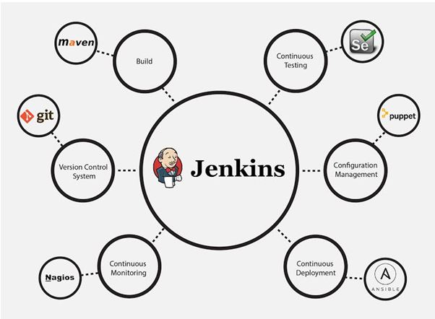
Once the project is configured in Jenkins then all future builds are automated. It has basic reporting features like status and weather reports (job health).
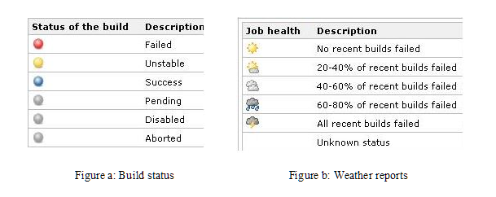
Most companies who handle continuous integration use their individual cloud-based continuous integration servers built on applications like Jenkins. With Jenkins, organizations can advance the software development process through automation. So overall to say, Jenkins integrates development life-cycle processes of all kinds which include building, documenting, testing, packaging, staging, deploying, static analysis and plenty more.

